|  |
| --- |
| Will open login page |

|  |
| --- |
| Press Login Button |

Story Board for LOGIN

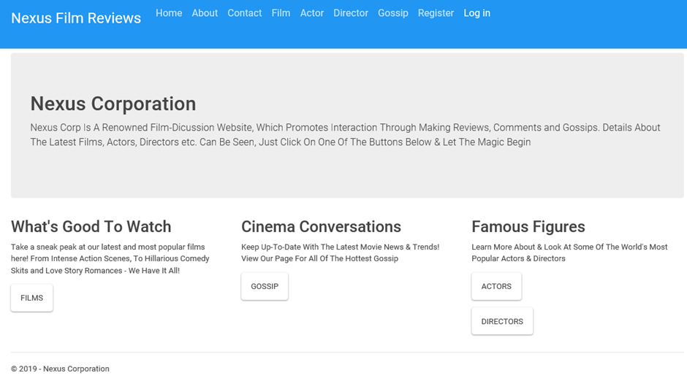 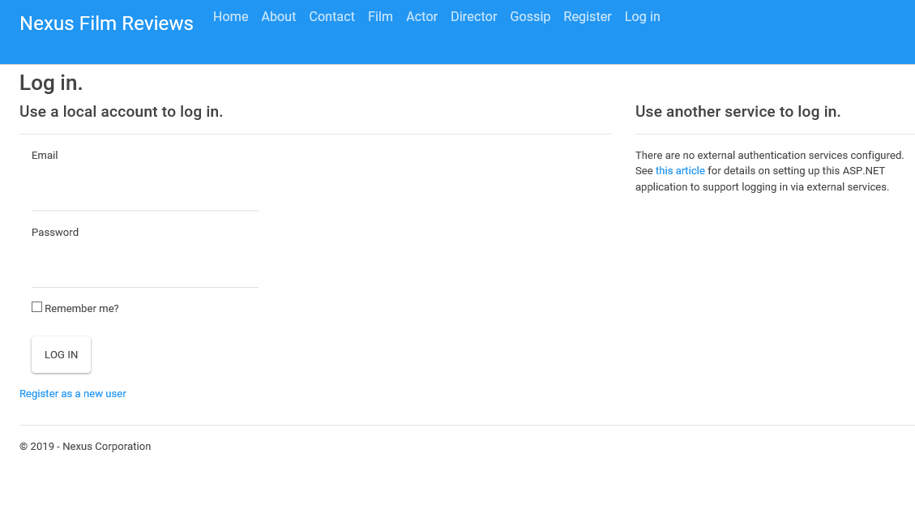

|  |
| --- |
| Press Register |

**Register**

 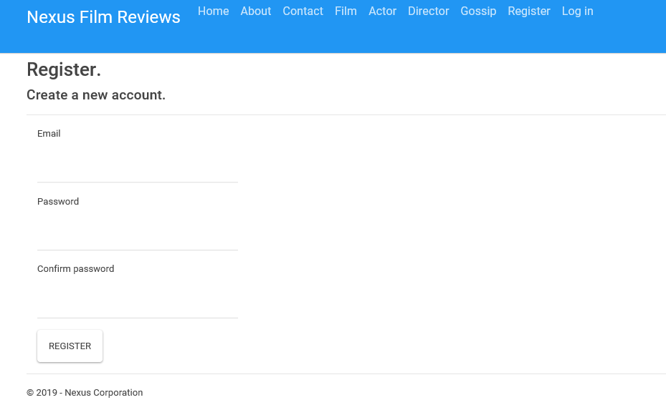

|  |
| --- |
| Click on About |

**Home Page**



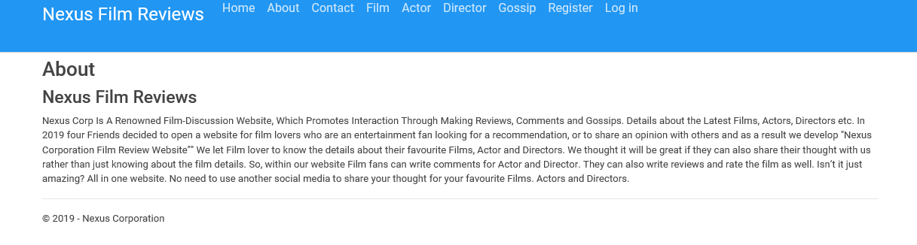

|  |
| --- |
| Click in contact |

**Contact Page**

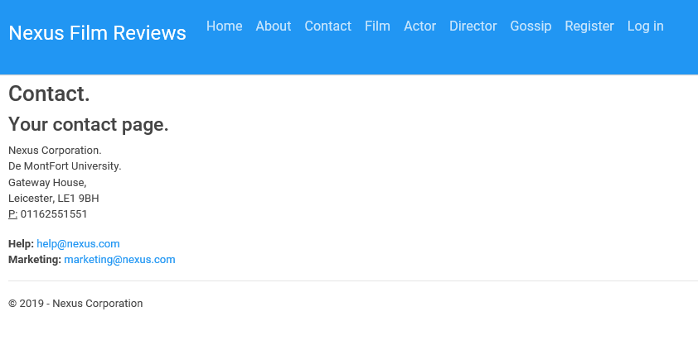

|  |
| --- |
| Click Film |

**Film Page**



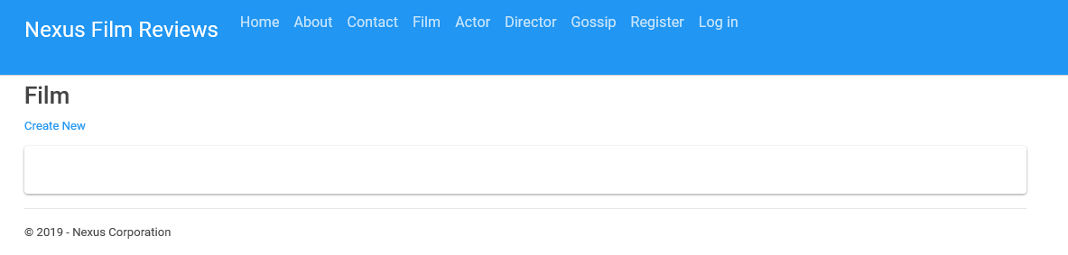

**Actor**



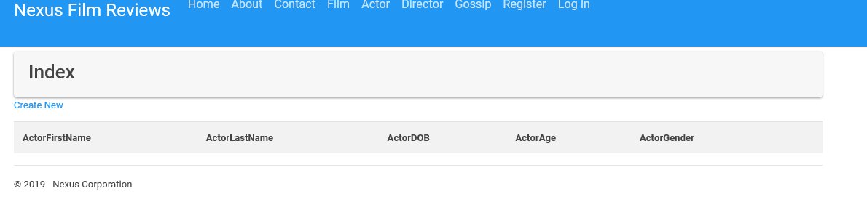

**Director**



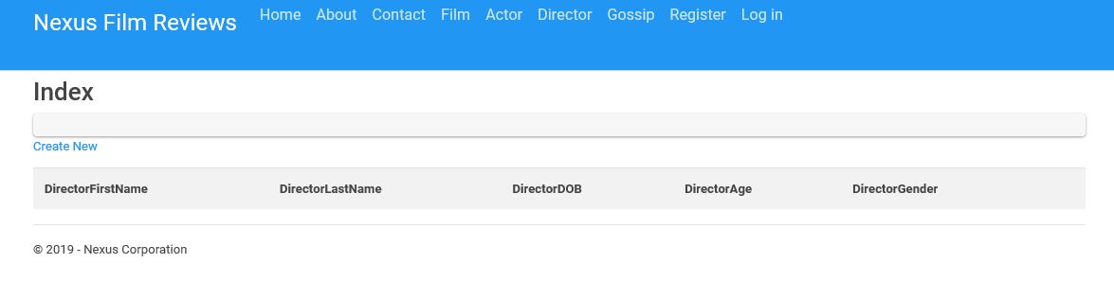

**Gossip**



